**Biomedical sensors (that can used with ESP32)**

* **Blood oxygen level + Heart rate** - MAX30100 Pulse Oximeter sensor:
  + Operating voltage – 1.8-3.3V
  + Low power consumption
  + Both BPM and Sp02 can be calculated using same sensor.

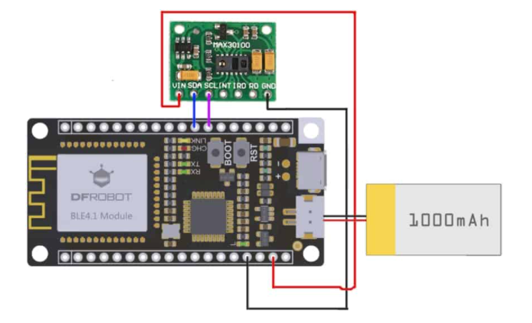

* **Heart rate** – Pulse sensor:
  + Low power consumption
  + Small and compact

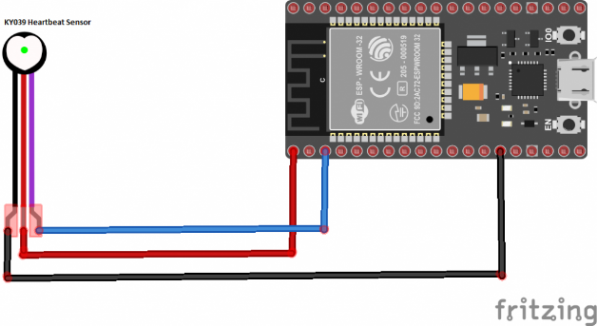

* **Heart rate** - KY-039:
  + Needs 5V
  + Not very easy to measure heart beat because of its design

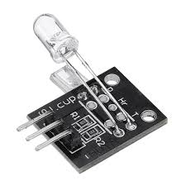

* **Body temperature** - DS18B20:
  + Good operating temperature range of -55ºC to +125ºC
  + Operating voltage – 3.0-5.0 V
  + Accuracy = +-0.5oC

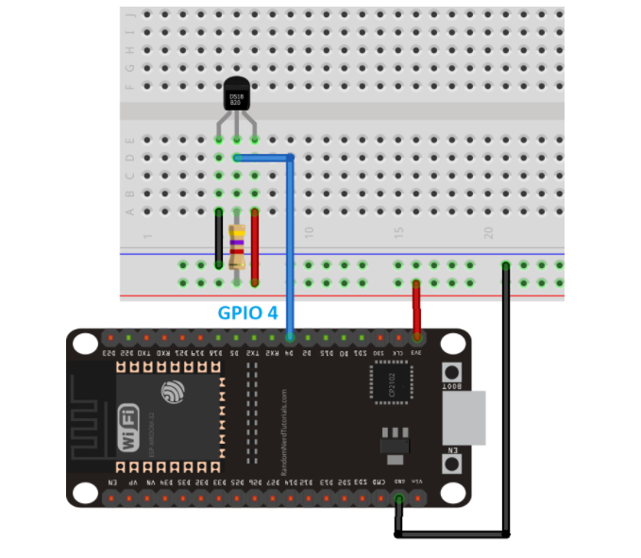

* **ECG -** AD8232 ECG Sensor**:**
  + Operates at 3.3V

